Hidden Nature inside Churches:

within the architecture and teaching

Inside every church you will find real examples of nature or symbols of living things. The obvious natural examples are the physical bread and wine at communion, water in the font at baptism, and flowers or wreaths at all types of celebrations such as Daffodils for Mothering Sunday and Christingles in Advent. In the season of Lent we don’t usually have flowers as it is a time of discipline preparing for Easter but at Harvest there is an abundance. We usually bring gifts in thanks that we have plenty to share with those who don’t. Last year we grew leeks in our Community Vegetable Bed and used them to make soup at our Messy Harvest event for local families. We also collect dry or tinned foodstuffs &/or educational stationery as our which are then are sent to local charity CART – Christian Africa Relief Trust who distribute them to a network of sustainable self- help organisations in Africa: Kenya, Cameroon, Malawi, Tanzania.

For Christmas at Christ Church last year we had three Christmas trees: one in church by the altar, one in the porch decorated with memory labels of those who have died but are still remembered with love at this special time of year, and for the first time we hosted the community’s Christmas tree in the graveyard. This was organised by the Sowerby Bridge Development Board and local groups held their carol services around it. Recently we have used the trunks of two Christmas trees to fashion a crude cross which replaces the ornate crosses in church throughout Lent and then is decorated with flowers to celebrate Easter Sunday.

This is a great example of how nature becomes a symbolic representation of our faith combining Jesus birth, his death on a cross and then appearing to his disciples though resurrection at Easter.
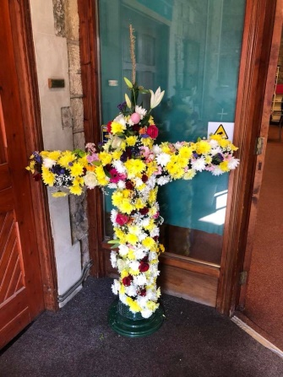
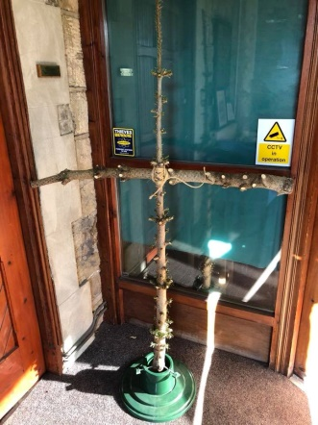
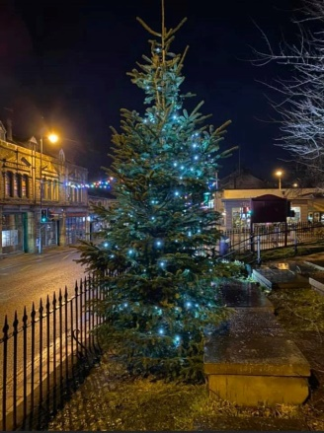

TREES AND PLANTS IN THE BIBLE
Trees and specific types of trees are often referred to in the Bible. There are the two trees in the Garden of Eden: one being the tree of life and one the tree of Knowledge of good and evil and the fig tree and an apple are linked in the Bible story of Adam & Eve. Noah’s ark was made of Gopher wood and after the flood the dove brought back an olive leaf to show that the water was receding. Moses sees a burning bush, and the Jewish temple was reportedly made from Cedar wood. Jesus was welcomed with Palm branches, forced to wear a crown of thorns and was crucified on the cross which was sometimes called “a tree”. Jesus also refers to many real trees and plants in his parables, the mustard seed, the wheat and the weeds.
However the Bible also uses images of trees symbolically. In particular Jesus calls himself “The Vine “those who believe in him “the branches” and God his father “the Gardener”. At the end of the Bible again we find the Tree of Life in heaven “bearing 12 kinds of fruit……. and with leaves giving healing for the nations”
This symbolism means that when we read the Bible passages about trees they can refer to a “family tree” as we use today when researching ancestry. In the Bible a tree represents life, with its roots as a foundation from which over time grows branches and leaves as generations of family as a sign of fruitfulness. Sometimes each person’s deeds are referred to as fruit and trees are pruned.
Isaiah gives a prophecy of “There shall come forth a shoot from the stump of Jesse, and a branch from his roots shall bear fruit” and The Tree of Jesse—a representation of Jesus’s genealogy in the form of a tree—became a popular subject in medieval Christian art. The first Jesse trees were large carvings, tapestries or even stained glass windows that helped people that could not read or write learn about the God’s story. There is a 14th century window in the nave of York Minster.
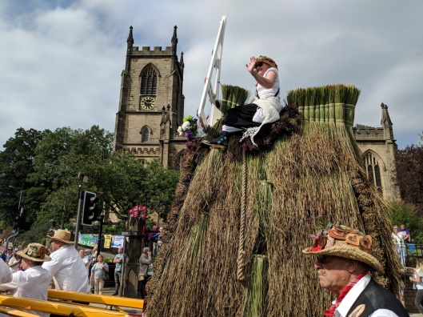
Here in Christ Church whilst most of our stained glass windows have central images of people, the outer edges often have leaves entwined, as though trained on a vine, and added flowers as decoration. In particular our Baptistry window (showing John the Baptist in the river Jordan) includes images of a palm tree and bull rushes in the scene and a dove depicting the Spirit of God descending on Jesus as He is baptized.
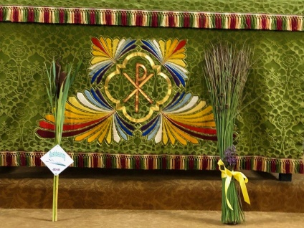
Real rushes cut from the moors above church are also displayed as part of our participation in the Rushbearing Festival held annually in September. This is to remember how every year fresh rushes were cut and used throughout the winter as floor coverings in churches and houses to trap the mud and dirt. In 1977 the tradition was revived with the return of the Rushcart parading through the communities of Warley, Sowerby Bridge and Ryburn, presenting rushes to each church on the 2 day route.
This year the 2020 presentation was very low key but recorded and can be seen on our Facebook page. https://www.facebook.com/Christchurchsb/videos/?ref=page_internal

ANIMALS IN THE BIBLE
After human beings the most common animal mentioned in the Bible is a sheep, and it is also probably the most significant.
Sheep are among the first animals to have been domesticated by humans. They were used by the early Jewish nation as a suitable offering to God and burnt as a ritual sacrifice to make up for the people’s wrongdoings, The Bible book of Leviticus lists them together with doves/ pigeons, bulls, goats and cereal crops. The Jewish feast of Passover centres on a spotless lamb being killed by each household to spare them from the 10th and final plague, that of the death of a first born son, before the Egyptian pharaoh let them go. Jesus is referred to by the prophet John the Baptist as “the Passover Lamb” and Christians believe that He like the Passover lamb laid down His life as a sacrifice to make it possible for those who believe to be reconciled with God. Jesus also referred to Himself as the Good Shepherd who lays down His life for his sheep and there are many references to lambs, rams, sheep and shepherds in the Bible. Shepherding was considered one of the worst occupations and shepherds were treated almost as outcasts from respectable society. David who fought and killed Goliath began life as a shepherd before being chosen as Israel’s King. At Christ Church the left hand stained glass window behind the altar features a lamb below the manger in the nativity scene and a shepherd as well as . The dove is also used as a sign of peace and to represent God in the form of the Holy Spirit, as in the Baptistry window. Other notable birds are ravens who fed the prophet Elijah in the desert, eagles that are seen as symbols of strength or warning and sparrows that though small are still valuable to God.
Fish too appear with the prophet Jonah being swallowed by a large fish, perhaps a whale, after being thrown overboard in a storm. He survived the ordeal in order to take God’s message to the city of Nineveh. Fish also play a large part in the ministry of Jesus as He called four fishermen to leave their trade and instead become “fishers of men” and share His message to other people so they became disciples. They were Simon who was given a new name of Peter, Andrew his brother, and another pair of brothers, James and John. There are miracles of Jesus feeding 5000 people with 5 loaves of bread and 2 fish, and later 4000 people.
Finally the gospel writers have traditionally been associated with the vision and prophecy by Ezekiel who saw four winged beings each with four different faces and four wings standing like men. They flashed like lightning and made a great noise that Ezekiel felt was spreading God’s message. This was deemed very significant when after Jesus died four of his disciples recorded what Jesus did and these writings formed the first four books of the New Testament part of the Bible. These men were given the status of saints and the four faces described by Ezekiel are each associated with one of them. St Matthew takes the form of a divine man, St Mark, a winged lion, St Luke a winged ox and St John an eagle. In Christ Church on the South aisle we have windows dedicated to these four gospel writers and our stone font which stands below them has these same four symbols carved into its side. You can read more about these windows on our website in the Church History section.
https://www.christchurchsb.org.uk/about-christ-church/our-history/the-windows-of-christ-church/
Our lectern from where the Bible is read is also in the form of a brass eagle again to emphasize that the Bible readings are holy words, inspired and sent by God.

